UML Diagrams

UML (Unified Modeling Language) diagrams represent the structure and functionality of the CarePulse Healthcare system. The following use case and activity diagrams illustrate the interactions between users and the system.
Class Diagram:
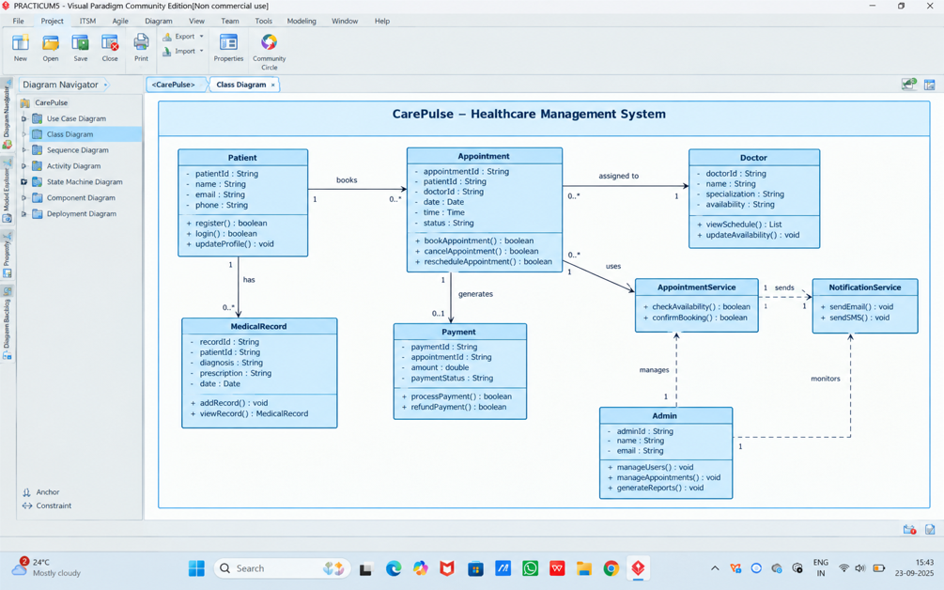
State Diagram:
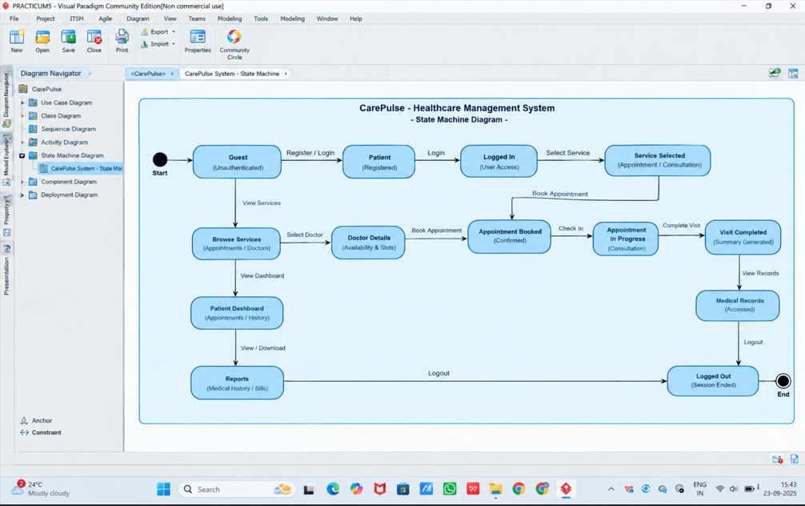

Sequence Diagram:
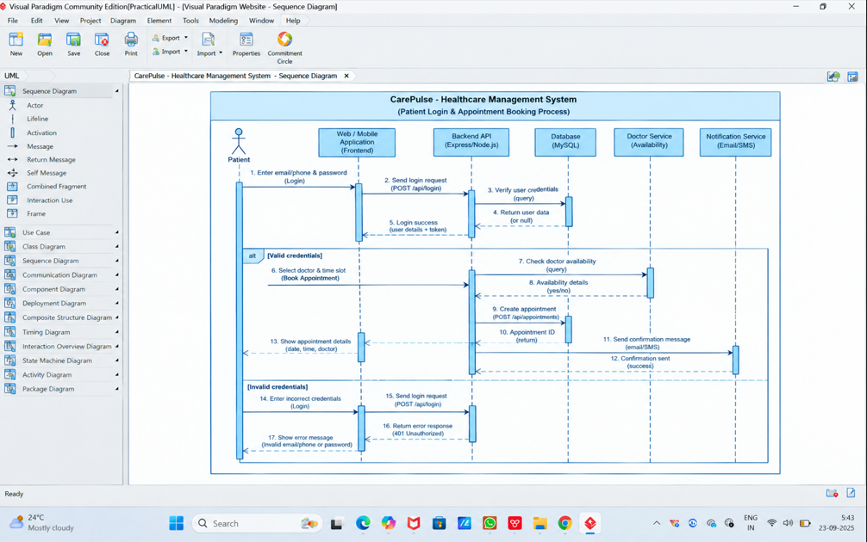
Use Case Diagram:
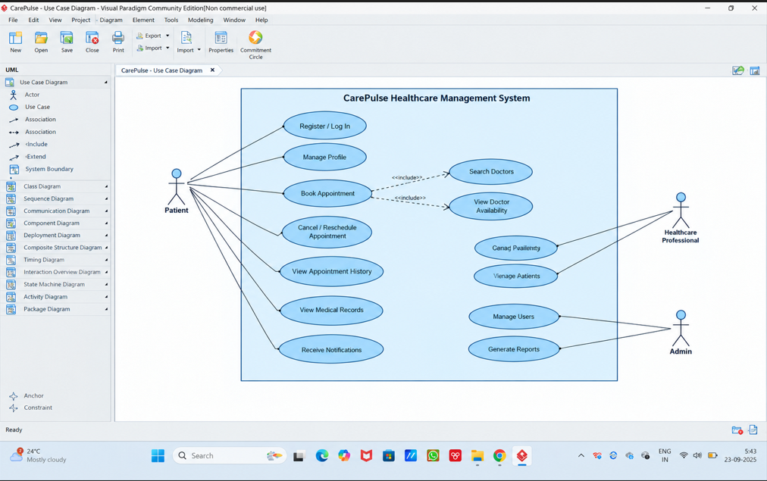

Activity Diagram:
